**­­­­­SVKM’s NMIMS**

**Mukesh Patel School of Technology Management & Engineering**

**Computer Engineering Department**

Program: B. Tech SEM-III

**Course: Data Structure and Algorithms**

**Experiment No.01**

PART A

(PART A : TO BE REFFERED BY STUDENTS)

**A.1 Aim:**

Write a program in C/C++ to implement the given scenario-using **Array**

**A.2 Prerequisite:**

1. Knowledge of different types of data structures.

2. Completed code of Task 1

2. Fundamental concepts of C\C++.

**A.3 Outcome:**

**After successful completion of this experiment students will be able to**

1. Identify the need of appropriate selection of data **structure ADD IN CONCLUSION/PARTLY/FULLY**
2. Identify the steps of appropriate data structure selection.
3. Explore the effect of appropriate data structure selection.
4. Differentiate types of data structure based on their organization of data.
5. Implement appropriate selected data structure to solve the given problem
6. Enlist the applications of different data structure.

**A.4 Theory:**

**A.4.1. Introduction of Data structure**

* The data may be organized into many different ways. The logical and mathematical model of a particular organization of data is called data structure.
* A data structure helps you to understand relationship of one data element with the other and organize it within the memory.
* Data structure specified following:
  + Organization of data
  + Accessing methods
  + Degree of associativity
  + Processing alternatives for information
* Classification of data structure:

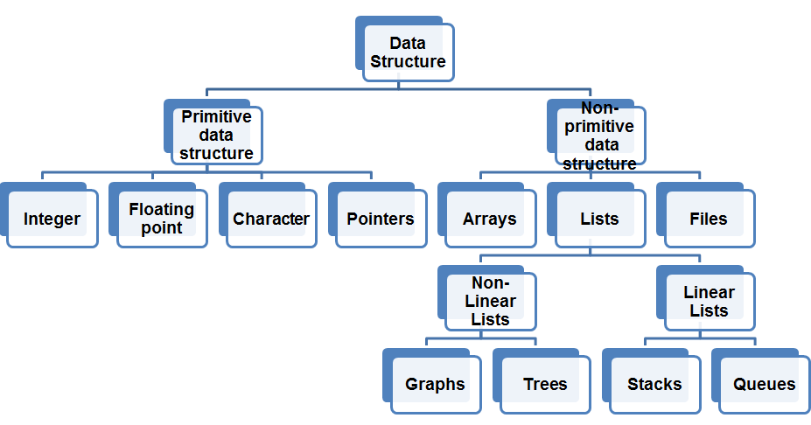

* Primitive data structure:
  + Basic structures
  + Directly operated upon by the machine instructions
* Non- Primitive data structures:
  + Derived from primitive data structure.
  + Emphasize on structuring of a group of homogenous or heterogeneous data structure.
  + Ex: Arrays, Lists, Files
* Various data structure:

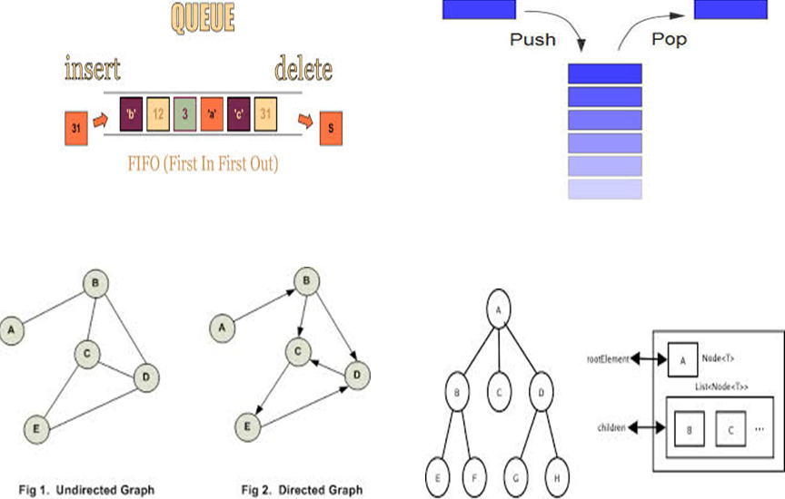

**A.5 Tasks / Procedures:**

**TASK 1:**

Write a C/C++ program of array to perform following **(1D Array)**

1. Program to traverse an array.
2. Find highest and lowest element in an array.
3. Delete an element from an array (by passing array to the function)

**TASK 2:**

A program has to be written that takes in student data like roll number, name and grade. It displays the same in the order of entry. It should have a function to provide the user option to choose to display of a particular student details given the name or the roll number.

**TASK 3:**

Identify suitable data structure for given scenarios. Specify reason for it.

1. To implement a system for reversing a word.
2. To implement printer spooler so that jobs can be printed in the order of the arrival.
3. To represent an image in a form of bitmap.
4. For representing a city region telephone network.
5. To store information about the directories and files in a system.
6. To implement a system for parsing syntax.
7. To implement back functionality in web browser.
8. To record sequence of all the pages browsed in one session.
9. To process network packets coming to the router.
10. To represent machines on internet and to find optimal path between source machine and destination machine to send data.
11. To represent connections\relations in social networking sites.
12. Google maps to travel from your home to office in minimum time.

PART B

(PART B : TO BE COMPLETED BY STUDENTS)

Students must submit the soft copy as per following segments within two hours of the practical. The soft copy must be uploaded on the portal at the end of the practical. The filename should be **DS_batch_rollno_experimentno Example: DS_E2_E001_Exp1**

|  |  |
| --- | --- |
| Roll No.1,32 | Name:Jagrit Acharya |
| Class :Data Structures | Batch :B1 |
| Date of Experiment: 7-07-20 | Date of Submission: 14-07-20 |
| Grade : | Time of Submission:10:00 AM |
| Date of Grading: |  |

**B.1 Software Code written by student:**

***(Paste your code completed during the 2 hours of practical in the lab here)***

**Task 1:**

**#include<stdio.h>**

**void traverse(float arr[],int n,int i)**

**{**

**printf("array traversing\n");//to traverse the whole array**

**for(i=0;i<n;i++)**

**{**

**printf("%f",arr[i]);**

**printf("\n");**

**}**

**}**

**float largest(float arr[], int n,int i)**

**{**

**float temp=arr[i];**

**for(i=0;i<n;i++)**

**if(arr[i]>temp)**

**temp=arr[i];**

**return temp;**

**}**

**float smallest(float arr[],int n,int i)**

**{**

**float temp=arr[i];**

**for(i=0;i<n;i++)**

**if(arr[i]<temp)**

**temp=arr[i];**

**return temp;**

**}**

**int delete(float arr[],int n,float temp)**

**{**

**float p=-1;**

**for(int i=0;i<n;i++)**

**if(temp==arr[i])**

**p=i;**

**if(p==-1)**

**printf("the number cannot be found in the array");**

**else**

**{**

**for(int i=p;i<n-1;i++)**

**arr[i]=arr[i+1];**

**n=n-1;**

**}**

**return n;**

**}**

**void main()**

**{**

**int n,i=0;**

**printf("enter the number of element you want in the array\n");**

**fflush(stdin);**

**scanf("%d",&n);**

**float temp,arr[n];**

**printf("enter elements of array one by one\n");**

**for(i=0;i<n;i++)**

**{**

**fflush(stdin);**

**scanf("%f",&arr[i]);**

**}**

**printf("\n");**

**char ch='0';**

**while(ch=='0')**

**{**

**printf("\npress '1' for traversing the array\n press 2 to get the largest number\n press '3' to get the smallest number\n press '5' to delete any element from the array\n press '0' for continue again\n press any number to exit\n");**

**fflush(stdin);**

**scanf("%c",&ch);**

**if(ch=='1')**

**{**

**traverse(arr,n,i=0);**

**ch='0';**

**}**

**else if (ch=='2')**

**{**

**temp=largest(arr,n,i=0);**

**printf("largest number=%f",temp);**

**ch='0';**

**}**

**else if (ch=='3')**

**{**

**temp= smallest(arr,n,i=0);**

**printf("smallest number=%f",temp);**

**ch='0';**

**}**

**else if(ch=='5')**

**{**

**printf("\nenter the element you want to delete\n");**

**scanf("%f",&temp);**

**n=delete(arr,n,temp);**

**printf("your element is successfully deleted\n");**

**ch='0';**

**}**

**else if(ch!='0')**

**break;**

**}**

**}**

**OUTPUT TASK 1**

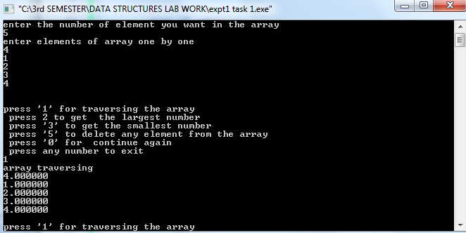

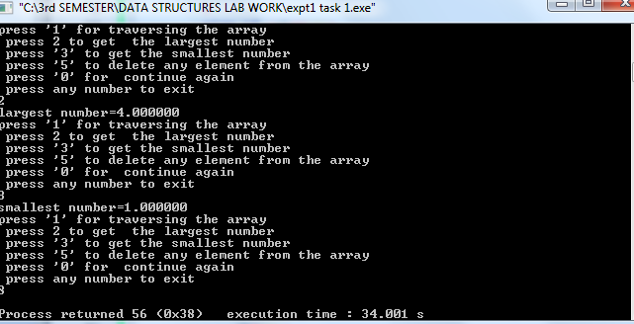

**Task 2:**

**#include<stdio.h>**

**# define q 100**

**struct students**

**{**

**char name[20];**

**int roll_no_;**

**float _marks;**

**};**

**void getdata(struct students a[],int n)**

**{**

**int i=0;**

**for (i=0;i<n;i++)**

**{**

**printf("enter student name\n");**

**fflush(stdin);**

**gets(a[i].name);**

**printf("enter student roll no\n");**

**fflush(stdin);**

**scanf("%d",&a[i].roll_no_);**

**printf("enter students grade marks\n");**

**fflush(stdin);**

**scanf("%f",&a[i]._marks);**

**}**

**}**

**int display(int r,int n,struct students a[])**

**{**

**int p=-1;**

**for(int i=0;i<n;i++)**

**if(r==a[i].roll_no_)**

**{**

**p=i;**

**}**

**if(p==-1)**

**printf("\nthe given roll no. is not there\n");**

**return p;**

**}**

**int main()**

**{**

**struct students a[q];**

**int n,r;**

**printf("enter no. of students\n");**

**scanf("%d",&n);**

**printf("now input data for each student one by one\n");**

**getdata(a,n);**

**printf("%f\n",a[0]._marks);**

**char ch='0';**

**while(ch=='0')**

**{**

**printf("enter the roll number of the students to get his/her data\n");**

**scanf("%d",&r);**

**r=display(r,n,a);**

**if(r!=-1)**

**{**

**printf(" student name is:\n");**

**puts(a[r].name);**

**printf(" student marks is:\n");**

**printf("%f\n",a[r]._marks);**

**}**

**printf("\n if want to exit press '2'\n if don't then press '0'\n");**

**fflush(stdin);**

**scanf("%c",&ch);**

**}**

**}**

**OUTPUT TASK 2**

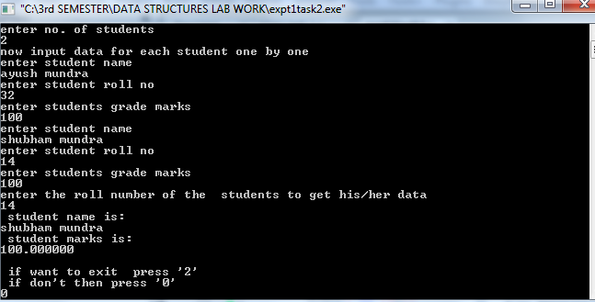

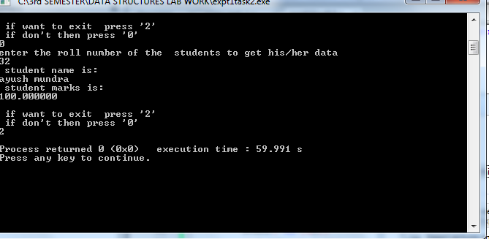

**B.2 Input and Output:**

***(Paste your program input and output in following format, If there is error then paste the specific error in the output part. In case of error with due permission of the faculty extension can be given to submit the error free code with output in due course of time. Students will be graded accordingly.)***

**Task 1:**

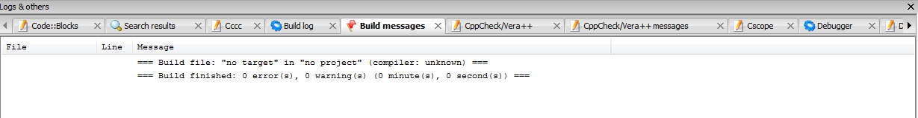

**Task 2:**

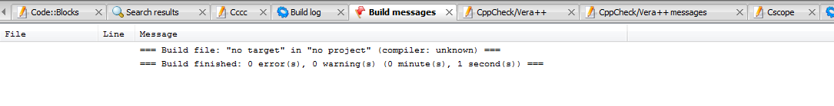

**B.3 Identified data structure with reason: (Task 3)/*learning from coding***

1. To implement a system for reversing a word.

ans ) We can use array for this. In an array if we move in a reverse loop and printing each element of the array one by one then we will get the reverse array.

1. To implement printer spooler so that jobs can be printed in the order of the arrival.

ans)Because printing has to be done in the order of arrival that means the one who will come first will print first i.e., first in first out(FIFO). Therefore we will use queue in it.

1. To represent an image in a form of bitmap.

ans)To represent an image in bitmap that is

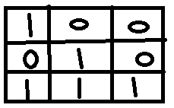

we need two dimensional array for it.

4. For representing a city region telephone network.

ans)To represent a city region telephone network we can use graphs.

6. To implement a system for parsing syntax.

ans)To implement a system for parsing index we can use queue(FIFO).

7. To implement back functionality in web browser.

ans)To implement back functionality in web browser we can use Stacks(LIFO).

8. To record sequence of all the pages browsed in one session.

ans) To record sequence of all the pages browsed in one session, we can use stacks and queue both.

9. To process network packets coming to the router.

ans) To process network packets coming to the router, we can use queue(FIFO).

10 To represent machines on internet and to find optimal path between source machine and destination machine to send data.

ans)We can use graph for it .

11. To represent connections\relations in social networking sites.

ans)We can use graph for it.

12. Google maps to travel from your home to office in minimum time.

ans)Best will be graph.

**B.4 Conclusion:**

*(****Students must write the conclusion as per the attainment of individual outcome listed above and learning/observation noted in section B.3)***

***All below mentioned points are my learning outcomes:***

***1)I have learnt "what is data structure?".***

***2)About Linear and Non linear data structures.***

***3)In Linear , I have learnt about Array and how to implement array by doing task 1 and task 2 of this practical.***

***4)I have also learnt about the various application where we use both Linear and non linesr DS.***

***5)Also well understood the concept of abstract data type like Queue, Stacks ,Tree and graph without yet implementing on codeblocks/coding.***

**B.5 Question of Curiosity *(To be answered by student based on the practical performed and learning/observations)***

Q1. Why appropriate selection of data structure is important in computer programming?

ans)Appropriate selection of data structure is important to choose while programming because-

1)It makes programming-Memory efficient use of space.

2)It increases the speed of the program and make it DRY

************************